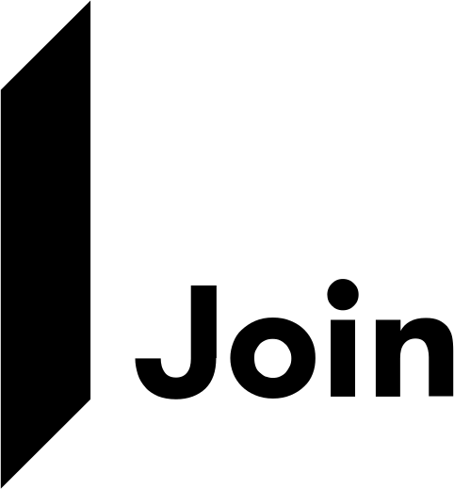
Pursuit Toolkit
RFQ / RFP
boilerplate language
Starter narrative for your proposal — organized by section, written to be rewritten. Make it sound like your firm, not like everyone else’s.

How to use this
- This is starter text, not a script. Owners read a lot of proposals — identical boilerplate blends in. Your edge is the story only your firm can tell, so rewrite it in your own voice and approach.
- Gray “starter text” panels are the language to adapt. Sand panels are guidance for you, not for the owner.
- Anything in orange is a placeholder — swap in the project, company, or design-team specifics before you send.
- Lead with what makes your team different: your delivery approach, your shared history with the design team, your results on similar projects.
Build with confidence.
Part of the Join Pursuit Toolkit · toolkit.join.build

Start here

The “About Join” narrative
Start with this wherever it best bolsters your win strategy — a technology section, an executive summary, or alongside your team’s services — then shape it to your firm. It states plainly what Join is and what it does for the owner.
Starter text — make it your own
About Join
Join is the preconstruction and design phase management platform that helps teams plan, evaluate, and deliver projects with greater efficiency and certainty. Project teams rely on Join to move faster, align stakeholders, and deliver a premier owner experience — from first concept to a fully procured, permitted, and constructible project.
What it means for the owner
Join gives owners real-time project oversight, with the ability to:
- Access cost data 24/7
- View the project timeline
- See design-phase and budget status at a glance
- Track the cost of every change
- Identify and reduce risk before it becomes a surprise
- Relay real-time, credible information to their financial partners
Why this lands
Owners describe the difference between a vendor and a partner as forward-looking versus backward-looking — a partner who reads the map ahead, not a reporter narrating what’s already done. This narrative frames Join as that forward-looking infrastructure, which is exactly what an owner is probing for.

Section · Cover letter

Introduce Join as part of a collaborative team
If collaboration is central to your win strategy, the cover letter is a strong place to position Join as a cornerstone of how your team works.
Starter text — make it your own
A highly collaborative team
The majority of our work is negotiated and delivered through collaborative project delivery methods, including Design-Build, CMAR, and IPD. [Company Name] and [Design Team Name] have successfully partnered on multiple highly collaborative projects, leveraging our shared expertise to drive efficiency and innovation.
Together, we have implemented Join, the preconstruction and design phase management platform, on our joint projects — resulting in greater efficiency, improved outcomes, seamless transparency, and a superior project experience for our clients.
[If space allows, name a specific shared project and its outcome to make the claim concrete.]

Section · Preconstruction & construction services

Join for managing cost, risk, and schedule
Consider placing this after your company’s services sections. If it fits, pair it with a Join screenshot to preview the collaborative environment (see the Demo Project Setup Guide for how to capture one safely).
Starter text — make it your own
On this project, we will use Join as the system of record for cost, risk, and schedule during preconstruction and design. Join gives the Owner and project team a single, shared view of how design decisions, scope changes, and risks impact the project in real time.
Instead of relying on disconnected spreadsheets and reports, Join connects estimates, risks, and schedules into one live model. As the design evolves, the Owner can see where the project stands, where it is trending, and what is driving those changes — creating greater transparency, faster decisions, and fewer surprises later.
For the full team, Join becomes the collaboration hub that keeps designers, trade partners, and preconstruction staff aligned around shared cost and schedule targets, delivering greater certainty before construction begins.
Preconstruction
Starter text — make it your own
During preconstruction, Join empowers teams to make data-driven decisions on every budget-impacting item. We visually track the project timeline and cost trendline in real time, keeping the project aligned with the Owner’s target timeline and budget. Stakeholders — including the Owner — can open any cost item, whether a potential addition or deduction, to review detailed breakdowns, options, and supporting materials. Simply put, the Owner has 24/7 access to project data and real-time cost insights.
Construction
Starter text — make it your own
Decision-making doesn’t stop at preconstruction. Join gives construction teams quick access to past project data to identify solutions for similar challenges, and serves as a centralized decision-making tool for:
- Managing and reviewing change orders
- Communicating the project timeline to stakeholders
- Tracking real-time contingencies and allowances
By integrating Join into our workflow, we enhance collaboration, minimize surprises, and keep the entire team aligned from start to finish.

Section · Project approach & risk mitigation

Join for mitigating risk
This is where Join can become a game-changer. When you lay out a tailored plan and the challenges you anticipate, show how Join helps the team identify, evaluate, and align on the thousands of decisions that move a project — so every stakeholder stays informed and working toward a shared vision.
Starter text — make it your own
Creating Items in Join is a powerful way to track, communicate, and mitigate project risk. Join lets stakeholders assess the potential cost and schedule impact of each identified risk while exploring mitigation strategies that prevent costly surprises as the project progresses.
Key project risks where Join supports mitigation:
- Expedited schedules
- Cost escalation
- Long-lead items
- Supply-chain disruptions
- Labor availability
- Code and AHJ requirements
- Existing conditions
By integrating risk management into Join, our team proactively addresses challenges, optimizes decision-making, and maintains project momentum.
Make contingency visible
Owners increasingly want to see contingency being managed, not just held — “a plan, not a cushion.” Tie this section to your risk register: every risk with an owner, a mitigation plan, and a cost exposure shows the owner you appropriate dollars deliberately rather than parking them and hoping.

Section · Relevant experience & innovation

Prove the track record, then the commitment
Two moves close this out. First, show experience: a grid of key team members and the relevant projects they’ve delivered together. Where you have it, weave in how the team hit compressed schedules, held or improved budgets, and met quality, safety, or sustainability metrics using Join — concrete proof, not assertion.
Use your own data
If your team already tracks decision history and outcomes in Join, that record is an asset. “Here are the thousands of decisions that moved this number” is far more convincing than a budget figure with no story behind it.

Second, reaffirm your commitment to equipping the team with the right tools and training to deliver a world-class experience.
Starter text — make it your own
Innovation and technology
[Company Name] is committed to investing in technology that empowers teams, streamlines design and construction, and delivers unexpected value to our clients and their projects. One of the most impactful tools we’ve implemented in recent years is Join — the preconstruction and design phase management platform that brings the design team, general contractor, and owner together in a single interface to make informed decisions and track schedule and cost impacts in real time, eliminating the inefficiencies of managing multiple systems.
Through our experience, we’ve found that Join:
- Strengthens data integrity for more reliable decision-making
- Accelerates decisions, keeping projects on track
- Aligns and engages all team members, driving momentum
- Keeps focus on owner and end-user objectives
- Gives owners 24/7 visibility into real-time schedule and cost impacts
- Builds owner confidence by reinforcing the team’s grasp of project goals

Before you send

A quick final pass
Starter text gets you most of the way; specificity wins the job. Run this checklist before the response goes out — the goal is a narrative that could only have come from your team.
- Rewrite at least one block in your own voice. If it reads exactly like the starter text, so will your competitor’s.
- Replace every orange placeholder with real names and project details.
- Name a shared project and a concrete outcome wherever space allows.
- Match the delivery-method language (Design-Build, CMAR, IPD, TVD) to this pursuit.
- Where you reference real-time cost or risk, consider a screenshot from your pursuit demo project.
- Read it aloud once — cut anything that sounds like a feature tour rather than the owner’s experience.


Want a hand putting this to work?
Your Join team can spin up a pursuit-ready demo tailored to your sector — healthcare, education, civic, and more — usually within a day. We’ll help you pick your focus areas, set your groupings, and talk through your flow.
Book a pursuit session → pursuit.join.build

